EEL-4742L Advanced Microprocessor Based System Design Lab Report

Section No: 1
Lab Instructor: Angel Salges
Lab No: 3
Lab Title: Modular Coding, Interrupts, and Low Power Modes
Name: Jacob Bachle
Partner’s Name: Rafael Cano
Date Performed: 2/3/26
Date Delivered: 2/3/26

Contents
EEL-4742LAdvanced Microcontroller Based Systems Design Lab Report 1
1. Introduction 3
2. Design Requirements 3
3. Theoretical Design 3
4. Synthesized Design 4
5. Experimental Results 4
6. Summary 4
7. Lessons Learned 5

Introduction
Lab 3 focuses on implementing modular coding techniques, hardware interrupts, and low power modes using the MSP432 microcontroller and DriverLib API. Rather than relying on polling-based delays such as the SysTick timer used in previous labs, this design replaces software-based timing with the MSP432 Timer_A hardware module. By using interrupt-driven execution, the processor can respond to events such as pushbutton presses and timer overflows without continuously executing delay loops. The design emphasizes modular programming by separating functionality into reusable functions for configuring I/O, handling pushbutton inputs, toggling LEDs, and configuring timers. Interrupt service routines (ISRs) are used to manage LED frequency changes and color transitions, while the microcontroller operates in Low Power Mode 0 (LPM0) to reduce energy consumption of the CPU. Since only the clocks that run timer A and interrupts need to be active for the design to function. The transition from polling to interrupt-driven control demonstrates improved efficiency, better code organization, and closer alignment with real-time embedded system design practices.

Design Requirements
When the device is powered on, LED 1 and the colored LEDs are all turned off and not blinking. Device is also in low power mode.

When switch 1 (S1), located on the left side of the board, LED 1 can be toggled to blink at the following frequencies, 1, 2, 4, and 0 (Off) Hz. The states are toggled when S1 is released.

When switch 2 (S2), located on the right side of the board, the colored LEDS can be toggled to different colors. The colors are Yellow, Cyan, Magenta, None (Off). The states are toggled when S2 is released.

The colored LEDs toggle at 1 Hz for all colors.

Pressing S1 or S2 to update the respective LEDs, causes the other LED to restart the cycle; the LEDs are synced.

Theoretical Design
Main Pseudo Code
- Stop WTD
- Config LEDs and Switches with interrupts as needed;
  - MAP_GPIO_registerInterrupt(GPIO_PORT_P1, pushButtons);
    - Updates states once S1 or S2 interrupt is detected
- Set default states (led1State = OFF; led2State = OFF;)
  - Update states defined globally
- Configure timer to toggle LED 1
  - Once timer reaches CCR0 set for timer base A0, toggle led helper is called. And toggles at respective frequency.
- Config timer to toggle LED 2
  - Once timer reaches CCR0 set for timer base A1, toggle led2 helper is called. And toggles respective color at 1 Hz.
- Configure MSP432 to enter low power mode once ISR is serviced
  - MAP_Interrupt_enableSleepOnIsrExit();
- Enable GIE (global interrupts (__enable_interrupts();))
- Enter low power mode 0 (MAP_PCM_gotoLPM0();)

Synthesized Design
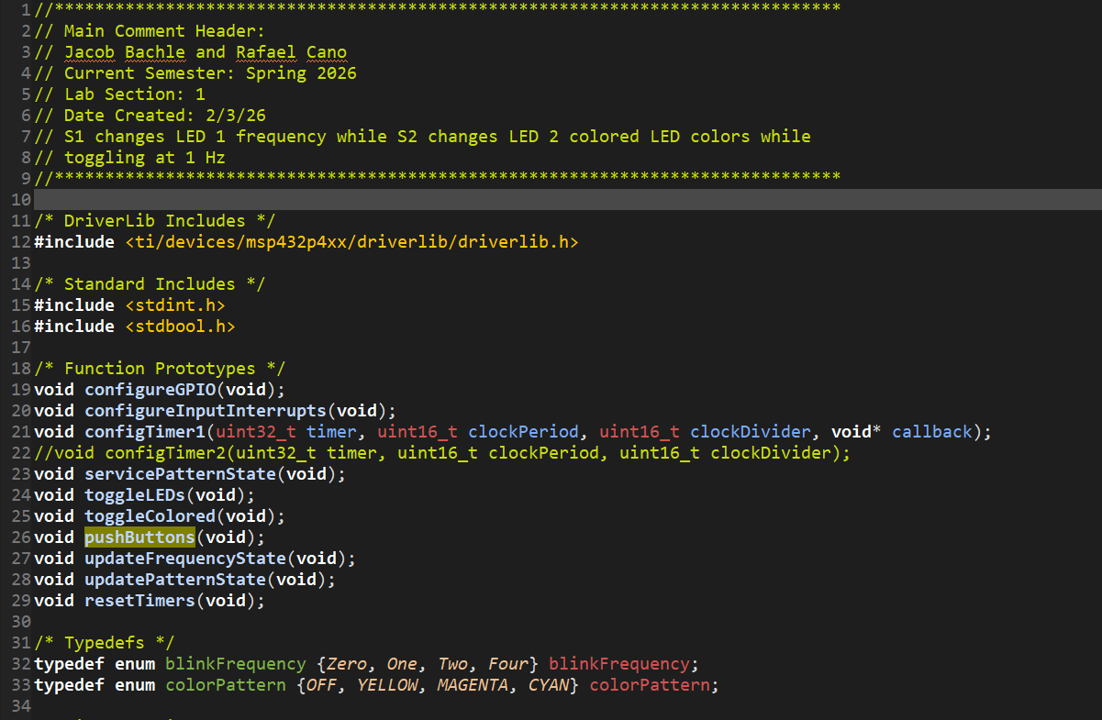
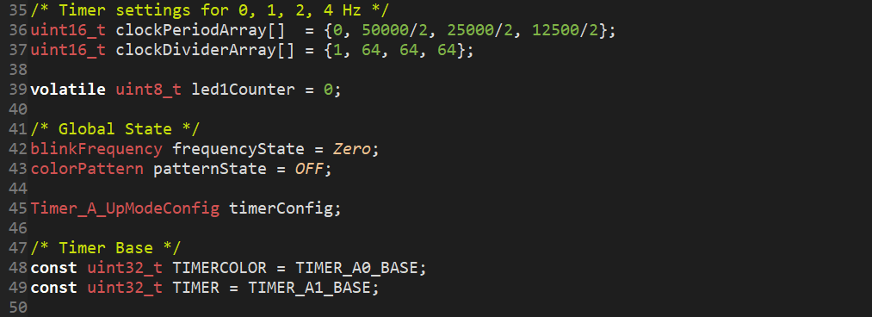
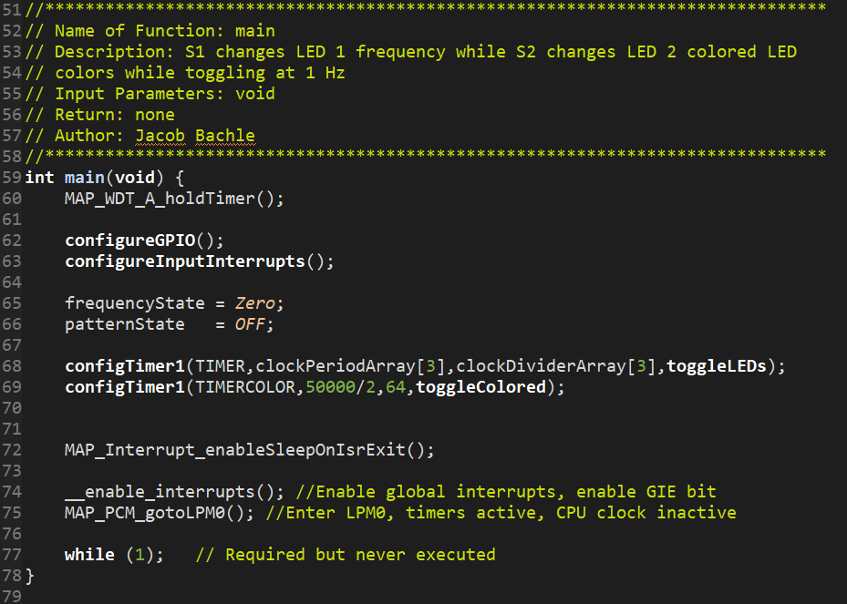
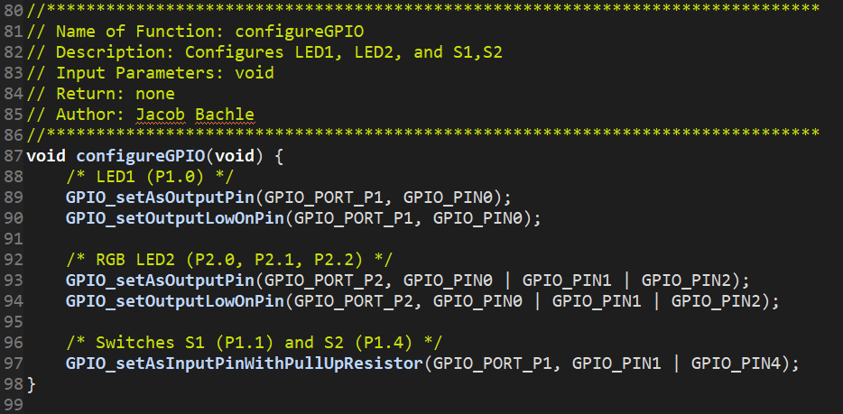
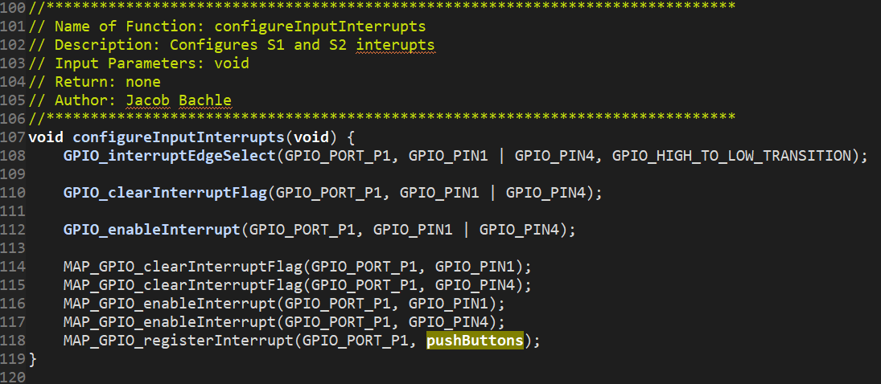
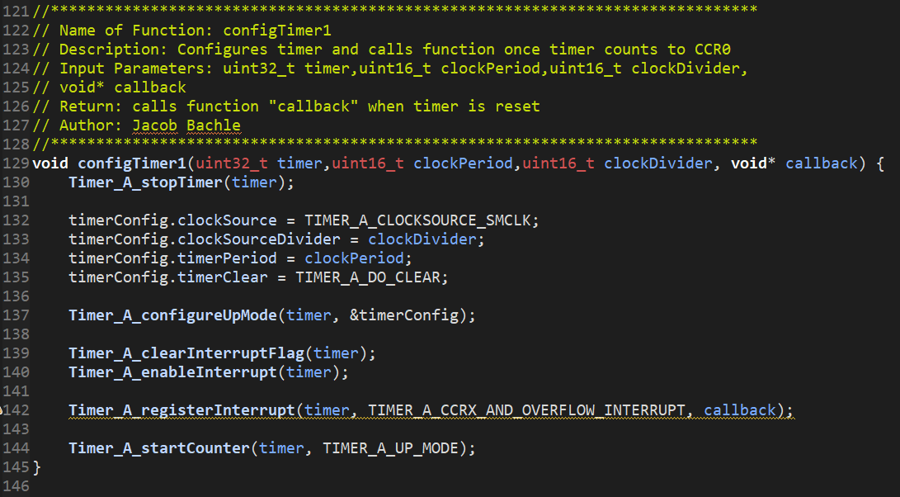
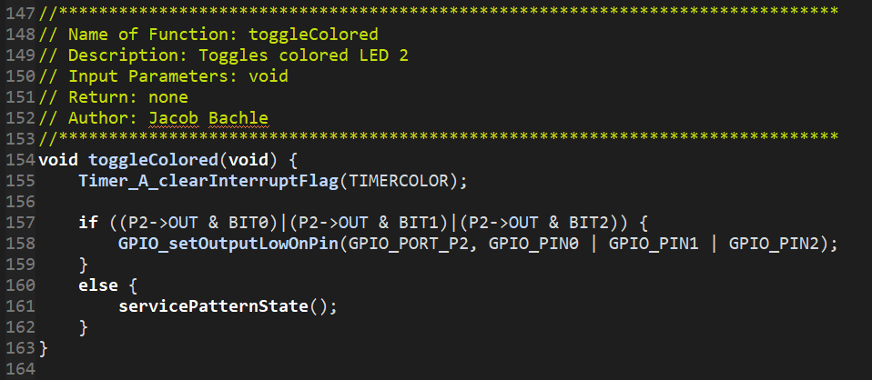
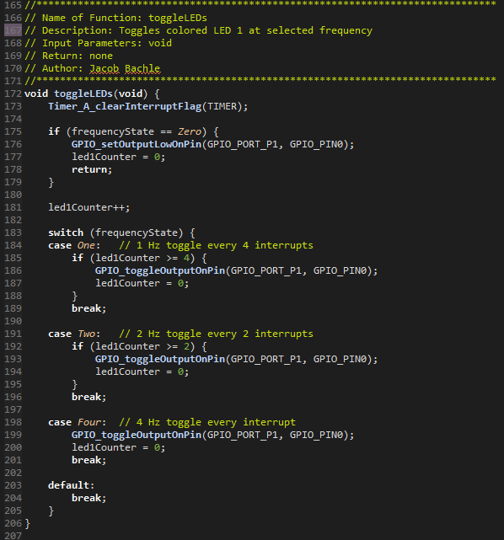
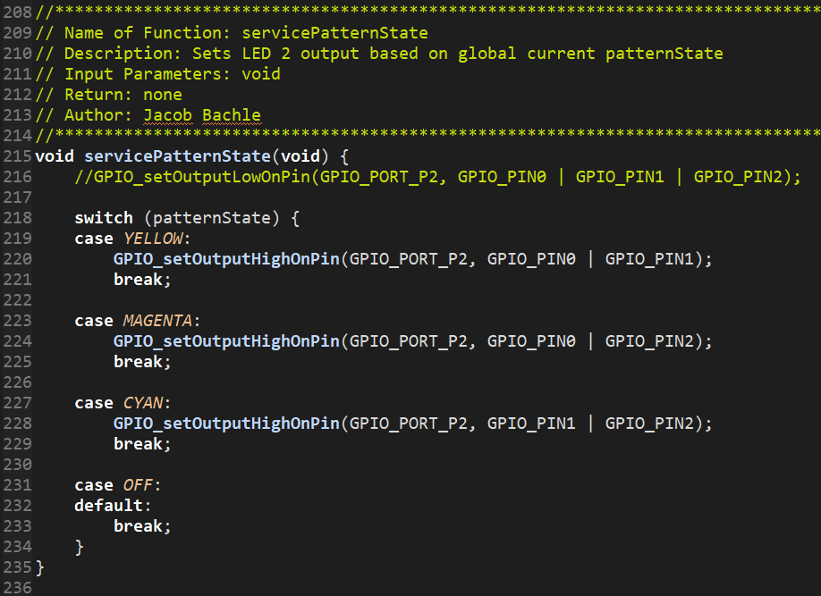
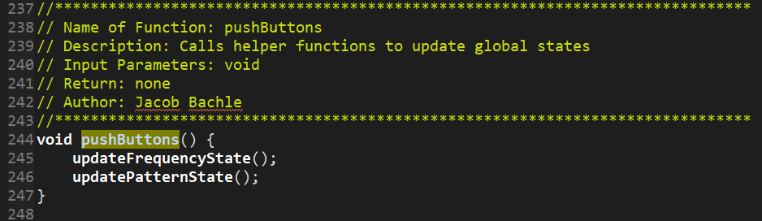
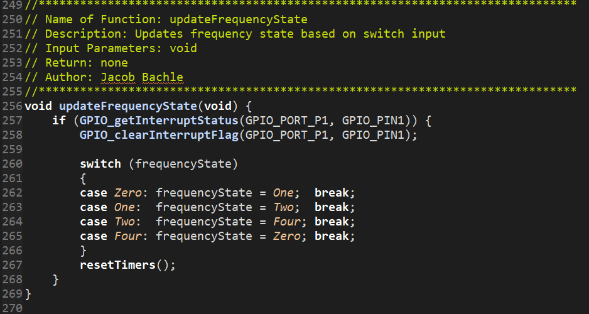
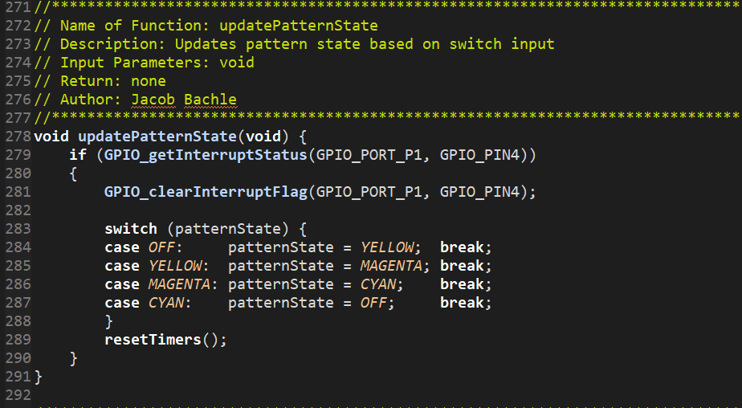
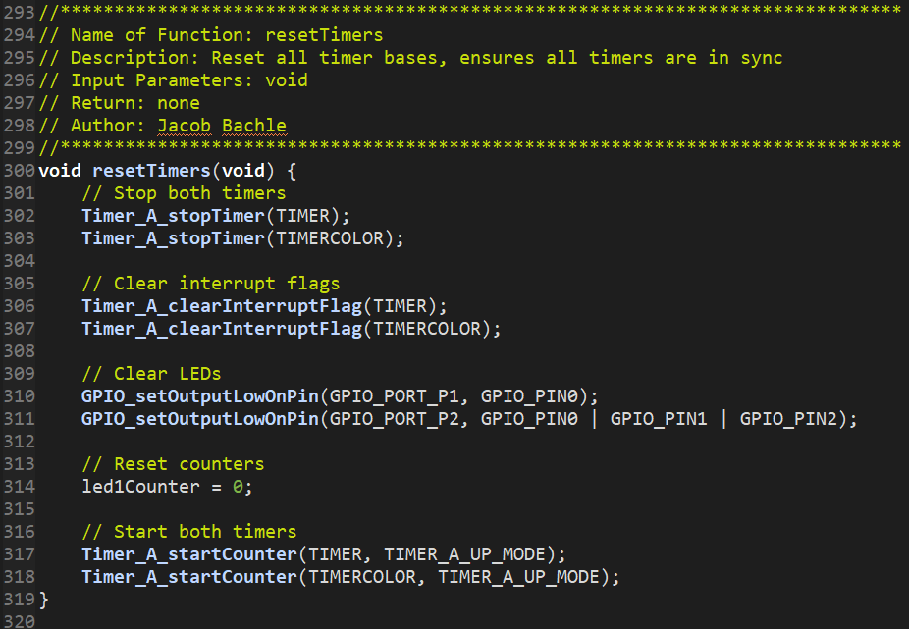

Experimental Results
The following certification is proof of design meeting design requirements.
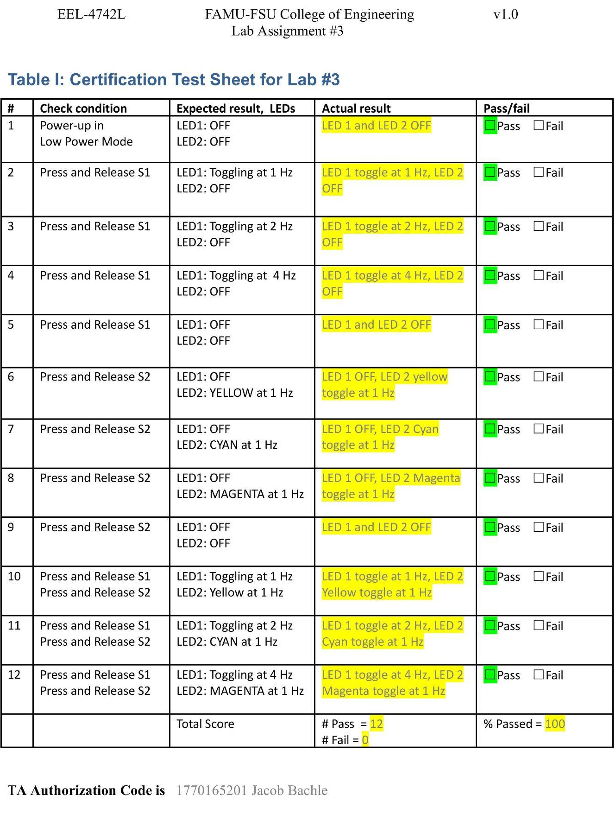

Summary
With the implementation of the previous logic defined in theoretical and synthesized design, all 12 out of 12 tests are passed. This means that 100% of the final design tests were passed and no further modifications needed to be made.

Additional Questions:
i. How did you implement changing frequencies of LED1?
A global state was defined as a typedef. Once the S1 or S2 interrupts are detected, the global state is updated based on the current state and implements proper wrapping to update the state to the next state. This then updates the global state to the proper current state. This is used to update the frequencyState which is a global variable storing the current frequency state. A timer with a high frequency is configured. Then once the timer reaches CCR0 (overflow is detected), a flag is set. This flag is used to reset the timer counter to 0. In addition, once this flag is detected, the helper function that toggles LED1 is called. A counter is incremented and based on the current frequency state, the counter is incremented or set to 0. This counter determines how many times the high frequency timer reaches CCR0, causing a discrete increase in frequency for each frequency state.

ii. Why do you need to clear an interrupt flag?
The interrupt flag is used to determine if an event occurred. If the interrupt flag is not cleared, it would appear that the event is occurring continuously. Logically, this would cause any code based on this interrupt flag to happen constantly.
iii. How did you implement toggling LED2 at 1 Hz?
A timer, with a different base than the timer used to control LED1 toggle frequency, was configured with a period of 1 second. Then once the timer reaches CCR0 (overflow is detected), a flag is set. This flag is used to reset the timer counter to 0. In addition, once this flag is detected, the helper function that toggles LED2 is called. This toggled LED 2 at the desired frequency (1 Hz).

Lessons Learned
List of new concepts learned or concepts improved upon:
- Using driver library functions to configure timer interrupt triggered functions.
- Using driver library functions to configure Px interrupt triggered functions.
- Using low power mode without interfering with operation.

